Connor Leu (ccl2396), Abdon Morales (am226923), Lauren Parker (lnp735)

Lab 2 - Pendulum Continued

Part 1
Method:
For Part 1, we decided to vary the masses attached to the pendulum to see if it would impact the period in a significant way. While other external factors may also alter the period (friction, human error), we believe the mass of the weight on the pendulum has the most direct effect on how the pendulum swings over time.

Our pendulum is about 35.5 cm +/- 0.05 long and we are collecting data on the weights of 10g, 20g, 50g, 100g, and 200g to determine if the mass changes the period. We predict that the heavier the mass, the larger the period.
When comparing our experiment design to another group, we had different approaches for how we planned to test our new hypotheses. Our group thought the mass of the pendulum would impact its period, while our neighboring group thought that the model was simply incorrect. Although our hypotheses were different, both groups aimed to collect more data on more runs than the previous experiment last week, to obtain more precise results.

Data:
We logged 4 periods for each mass and averaged them per angle tested. The chart below contains the period data, followed by a visual graph.

Time error +/- 0.01s
 | Angle (°)
Mass (g) | 10 | 15 | 20 | 25 | 30
10 | 1.26 | 1.2475 | 1.245 | 1.27 | 1.27
20 | 1.26 | 1.26 | 1.27 | 1.2675 | 1.28
50 | 1.275 | 1.28 | 1.2825 | 1.29 | 1.29
100 | 1.28 | 1.28 | 1.29 | 1.3 | 1.3
200 | 1.29 | 1.2875 | 1.295 | 1.3 | 1.31

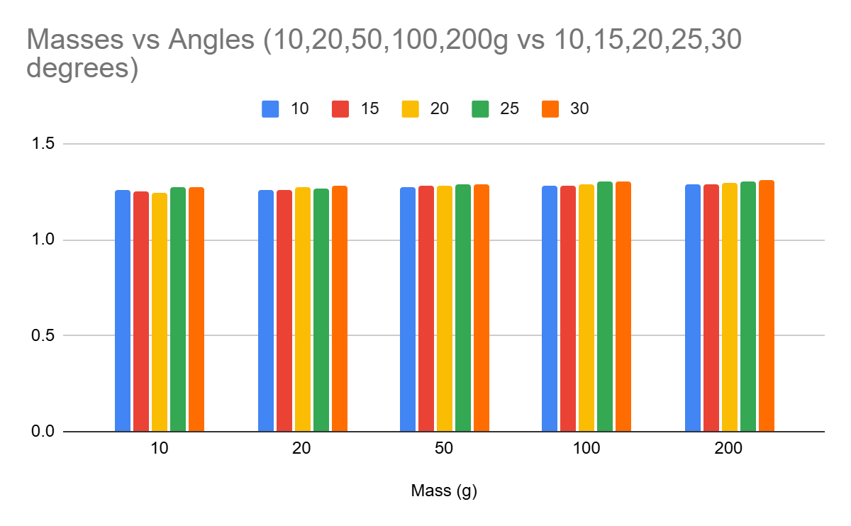
Conclusion
We conclude that the mass does not significantly contribute to the pendulum period, which contradicts our initial hypothesis. As displayed in the chart above, we have a slight general upward trend with both the masses and the angles, where the larger masses/ larger angle from which the pendulum has swung leads to higher periods.

The range of values obtained when altering the masses being swung from the pendulum had a far smaller range of values than the values we attained last week, where we kept the mass of 20g. Due to the measurements, we aren’t sure if it was the angle or the mass that had a greater impact on the pendulum time. Due to this, we will be testing the angle in Part 2.

Part 2
Method
Due to our conclusions obtained from Part 1, we will be testing the angle of the pendulum to determine if that significantly impacts the period. Our data from Part 1 tells us that one of the two (mass or angle) impacts the period.

Due to the lack of variance by changing our masses from Part 1, we will maintain the weight for this part (50g) and vary the angle significantly. We believe the equation for the period of a pendulum should take into account the angle from which it is being dropped.

Data
We measured the average period of 4 measurements per angle, in increments of 5 degrees, from 15 to 60 degrees. The following chart highlights the data:

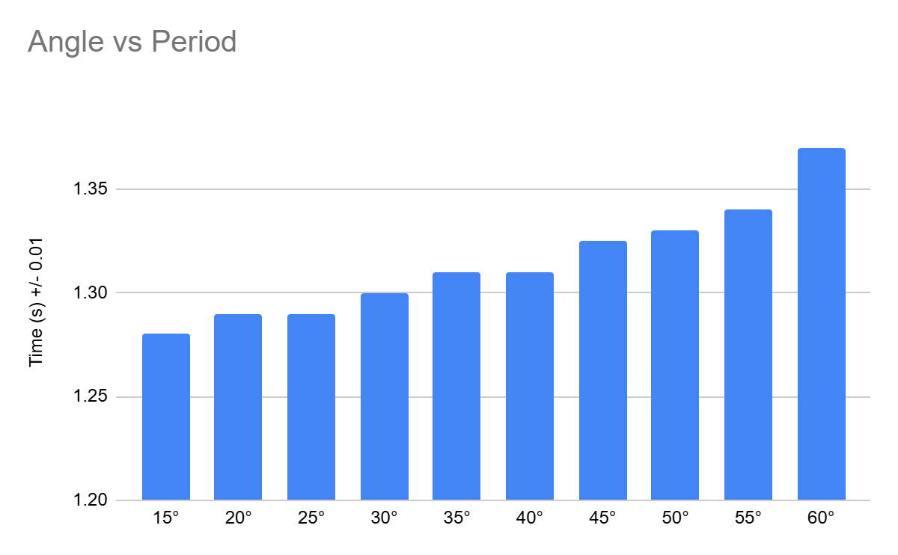
As we can see from the graph, the angle from which the pendulum is swung does notably impact the period. We believe that the pendulum equation should take the angle into account as a primary factor, scaled by some constant, turning it to look like:
$T=2π*αθ*\sqrt{\frac{l}{g}}$
The angle should be considered in radians to keep with standard units. We did not collect enough data to accurately come up with a value for our scaling factor alpha, but due to the angle’s direct impact on the pendulum time, higher values of theta should directly increase T, hence it not being under the square root.

As an aside: the elliptic integral solution for pendulums exists, which does this exact thing! But with a lot more math. We found a write-up at this link. Cool stuff.

Conclusion:
We conclude that angle has a significant impact on the pendulum’s period. After swinging a 20g mass at varying angles from 15° to 60°, we obtained pendulum periods from 1.28s to 1.37s (+/-0.05s uncertainty). Compared to the experiment that we conducted in Part 1, this wider range of values indicates the greater impact of the angle the pendulum is swung from on period in comparison to the pendulum’s mass.

Additionally, we noted that the larger the angle from which the pendulum was swung, the larger the variance in period values. For example, when swinging the pendulum from 15°, all 4 periods of the run were 1.28s, while when swung from 55°, the 4 periods of the runs were 1.32s, 1.35s, 1.35s, and 1.34s. The variations in these values could be attributed to general uncertainty, but given the upward trend in period times, we strongly believe that this is due to the impact that angle has on the period.

This experiment could be improved with better and more precise testing equipment, as well as taking more samples per angle. This would give us more data to more accurately account for any error and better compute the impact of the angle on the period.

